### **Stakeholders**

The stakeholders of Elasticsearch are categorized according to the stakeholder types described in Rozanski & Woods (2012), including three additional types: competitors, investors, and marketers. The categories have been placed in alphabetical order. The categories have been placed in alphabetical order.

|  |  |
| --- | --- |
| **Type** | **Stakeholders** |
| Acquirers | The Elastic company itself, mainly its founders, leadership, and board. |
| Assessors | Baird Garett (Senior Vice President of Legal) and Robin Sharpe (Vice President of Operations). |
| Developers | Every contributor on GitHub. The three biggest contributors we identified are Shay Banon (@kimchy, creator of Elasticsearch), Simon Willnauer (@s1monw, founder) and Jason Tedor (@jasontedor, currently most active developer). |
| Investors | Elastic company. Elastic [is funded by](https://www.elastic.co/about/board" \t "https://delftswa.gitbooks.io/desosa2018/content/elasticsearch/_blank) three main investors: Benchmark Capital, Index Ventures, and New Enterprise Associates Inc. (NEA). |
| Maintainers | Large overlap with developers. The three most active are Jason Tedor, Simon Willnauer and Jim Ferenczi |
| Marketers | Elastic has 'Go-To-Market' partners, who help market Elasticsearch. A list of over 25 of these partners is available [here](https://www.elastic.co/about/partners/go-to-market" \t "https://delftswa.gitbooks.io/desosa2018/content/elasticsearch/_blank). |
| Suppliers | Apache Lucene provides the base functionality of Elasticsearch, with Elasticsearch providing a REST API on top of Lucene, among other functionalities. Elasticsearch also runs on Apache Hadoop, Amazon Web Services (AWS), and Google Cloud Platform (GCP), thus making Apache, Amazon, and Google their main suppliers. |
| Support staff | Marty Messer (Vice President of Customer Care). Elastic also provides [subscriptions](https://www.elastic.co/subscriptions" \t "https://delftswa.gitbooks.io/desosa2018/content/elasticsearch/_blank) for dedicated support for Elastic's products. Elastic's [open forum s](https://discuss.elastic.co/c/elasticsearch" \t "https://delftswa.gitbooks.io/desosa2018/content/elasticsearch/_blank)handle general questions on using Elasticsearch. |
| System administrators | IT departments of the companies that use Elasticsearch, as well as the people who manage the [Elastic Cloud](https://www.elastic.co/cloud" \t "https://delftswa.gitbooks.io/desosa2018/content/elasticsearch/_blank) platform. |
| Testers | Most developers are also testers. One contributor stands out in his involvement in testing as well as documentation: Luca Cavanna. |
| Users | A large number of users, both simple individuals as well as large companies, use Elasticsearch. Some of the largest users include [Sprint](https://www.elastic.co/use-cases/sprint" \t "https://delftswa.gitbooks.io/desosa2018/content/elasticsearch/_blank), [eBay](https://www.elastic.co/videos/ebay-and-elasticsearch-this-is-not-small-data" \t "https://delftswa.gitbooks.io/desosa2018/content/elasticsearch/_blank), and [Zalando](https://www.elastic.co/videos/creating-the-fashion-experience-of-the-future-with-elasticsearch-at-zalando" \t "https://delftswa.gitbooks.io/desosa2018/content/elasticsearch/_blank). |

### **Power/Interest grid**

Each of the stakeholder categories mentioned above has been included in the grid.The various types of stakeholders can be placed in a Power/Interest grid, which shows the interest that each stakeholder category has in the system versus the power they have to influence the system. The grid is shown below:

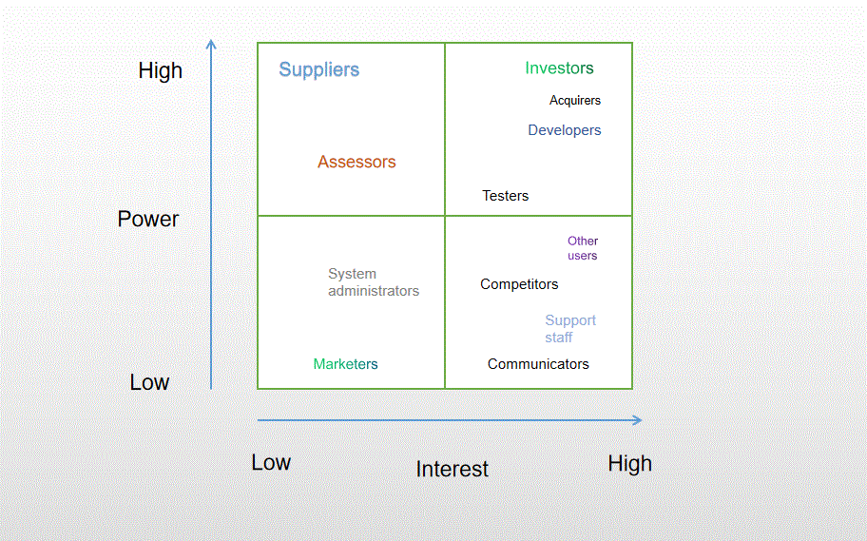

While users have a high interest in Elasticsearch, suppliers do not, although they do have a high power over Elasticsearch; should they decide to stop supplying their product, then Elastic will have to adapt their products accordingly. Marketers, on the other hand, have hardly any power over Elasticsearch and are mainly interested in its core and/or most impressive features to use as selling points.